# **Exploring the Dynamics of Friendships Formed Through Dating Apps: Analyzing Reddit Entries**

Keywords: friendships, dating apps, Tinder, Reddit analysis, user-generated content, web scraping, modern relationship trends

## Introduction

Friendships formed through dating apps like Tinder represent a shift from traditional methods of making friends, reflecting modern relationship paradigms. This study focuses on understanding the dynamics of these friendships by analyzing user-generated content on Reddit. The importance of this study lies in its potential to reveal insights into the evolving dynamics of friendships within the context of dating apps. By focusing on a specific online community, it contributes to a deeper understanding of how social, cultural, and individual factors influence the formation and evolution of these relationships.

## Literature Review

Web scraping is an invaluable tool for collecting data from social media platforms, enabling researchers to analyze trends, sentiments, and patterns within user-generated content. As social media continues to grow as a primary medium for communication, the methodologies employed in web scraping have evolved to address both the technical and ethical challenges of data collection. This review synthesizes recent advancements and applications of web scraping methodologies, focusing on the scraping of comments and entries on platforms like Reddit.

Xu et al. (2024) emphasize the importance of clean data curation through neural web scraping for pretraining language models. They argue that the precision of data collection significantly impacts the performance of language models, underscoring the need for advanced scraping methodologies that can intelligently filter and collect high-quality data from social media platforms.

Studies on web scraping methodologies demonstrate its potential to extract valuable insights from multimodal social media content. For instance, Jalal et al. (2019) developed methods to scrape and analyze Instagram photos to detect and analyze food types, showcasing how web scraping can be used to analyze visual and textual content related to various topics, including friendships formed through dating apps.

Using pretrained language models for detecting specific themes in social media comments showcases how web scraping combined with advanced analytical tools can uncover underlying sentiments and attitudes within online discussions (Bhandari and Goyal, 2022). This approach can be employed to identify conversations about friendships on dating apps, providing a deeper understanding of societal perceptions and the emotional landscape surrounding these relationships.

Kathi et al.'s work on classifying toxic comments on social media using machine learning models highlights the importance of maintaining a healthy online discourse. This research approach can be adapted to study communication patterns within friendships from dating apps, identify potential indicators of unhealthy dynamics, and explore how digital platforms facilitate or hinder positive interactions among participants (Poojitha et al., 2023).

AbuSalih et al. provide a foundational understanding of the vast potential of social media data and the insights it can offer into user sentiments, preferences, and behaviors. These studies emphasize the importance of analyzing user-generated content for extracting meaningful patterns related to relationship dynamics, employing methodologies like sentiment analysis and trend prediction.

Overall, these studies underline the potential of web scraping and advanced analytical techniques in uncovering the nuanced dynamics of friendships formed through dating apps. This literature provides a solid foundation for exploring the complex interplay of social, cultural, and individual factors that influence these relationships.

## Methodology

The methodological approach involves analyzing user-generated content, such as thematic analysis or sentiment analysis, to uncover prevalent sentiments and emotional dynamics related to friendships from dating apps. These findings illustrate the complex interplay of cultural, social, and individual factors influencing the formation and evolution of these friendships, providing concrete examples from the data to support research questions. This section outlines the web scraping methods used to collect data from Reddit threads discussing experiences and thoughts about forming friendships through Tinder.

I employed Python-based libraries such as Selenium for HTML parsing and Scrapy for data scraping. Given the sensitivity of the data and privacy concerns, my methodology strictly adheres to ethical web scraping guidelines. This includes respecting anonymizing data, and obtaining publicly available data without infringing on user privacy.

Data preprocessing has been utilized to clean the scraped data to prepare for sentiment analysis and text mining techniques. The stepbystep data preprocessing process includes:

1. Data Collection: Scraping user generated content from Reddit using Selenium and Scrapy.
2. Data Cleaning: To accurately analyze the scraped data, data preprocessing is necessary to clean the data and prepare it for sentiment analysis and text mining techniques. The data preprocessing steps included:

* Removal of Irrelevant Information: The process of filtering out nonessential data, such as advertisements, unrelated comments, and other noise that could skew the analysis.
* Text Normalization: This involved converting all text to lowercase, removing punctuation, special characters, and stop words, and performing stemming or lemmatization to reduce words to their base forms.

1. Tokenization: Splitting text into individual words or phrases to facilitate analysis.
2. Stemming and Lemmatization: Reducing words to their root forms to ensure uniformity in text analysis.
3. Identification of Key Phrases: Extracting relevant phrases and terms that align with the research questions.
4. Sentiment Analysis Preparation: Structuring the cleaned data for sentiment analysis to gauge the emotional valence of discussions.
5. Data Mining Techniques: Applying algorithms to identify patterns, trends, and common themes within the data, enabling a deeper understanding of the experiences and sentiments surrounding friendships formed on Tinder.

Those are the Reddit entries that have been scraped and analysed:

* What do you think "New friends" really means?
* Girls who select Looking For: “New Friends” on Tinder:
* What's the deal with people "only looking for friends"?
* Have you made legitimate, lasting friendships with people you met on a dating app?
* Using Tinder for friends only. Bf is being weird about it; how do I convince him Tinder is an option for making friends?
* People who are "only looking for friends" on Tinder are the worst
* There should be an app like Tinder but for finding friendships

### 3.1 Web Scraping

Steps to Scrape Data from Reddit Using Scrapy and Selenium

1. Libraries: Imports necessary libraries for web scraping and browser automation.

2. Spider Class: Defines a class to handle the scraping process.

3. Initialization: Sets up the Selenium web driver.

4. Parse Method: Navigate to the URL and scroll to load all comments.

5. Comment Selection: Extracts and yields the comments using CSS selectors.

6. Cleanup: Closes the browser once the task is complete.

##### Libraries

The first step is to import the necessary libraries.

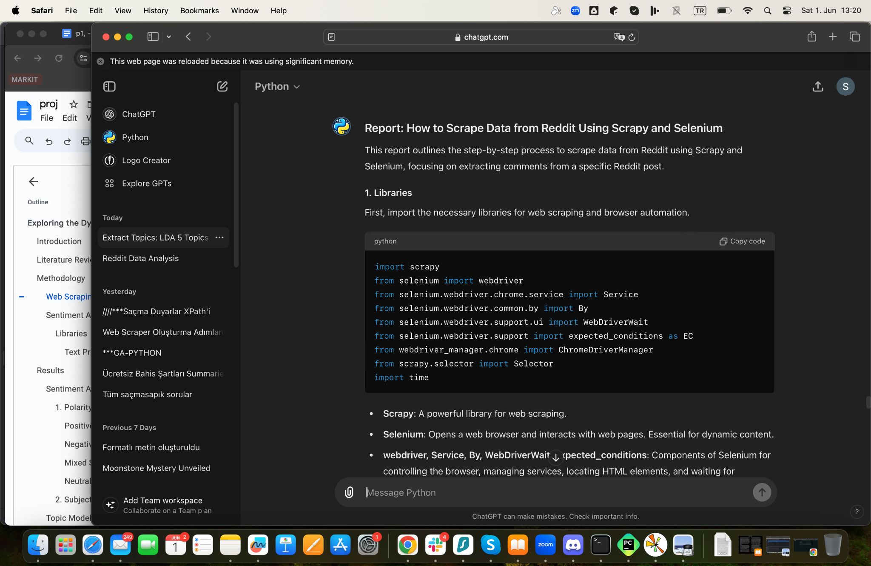

1. 'import scrapy'

Scrapy is a library for web scraping that helps extract data from websites.

2. Selenium and its related libraries

Selenium: This opens a web browser and interacts with web pages according to the code. It is useful for websites that use dynamic content (JavaScript).

webdriver: Controls the browser.

Service: Manages services like ChromeDriver.

By: Locates HTML elements.

WebDriverWait and expected_conditions: Waits for certain conditions before proceeding.

ChromeDriverManager: Automatically downloads and installs ChromeDriver.

3. 'from scrapy.selector import Selector'

Selector: Helps to select specific parts of a web page using CSS selectors.

4. 'import time'

time: Used to pause the script for a specified amount of time.

##### Spider Class Definition

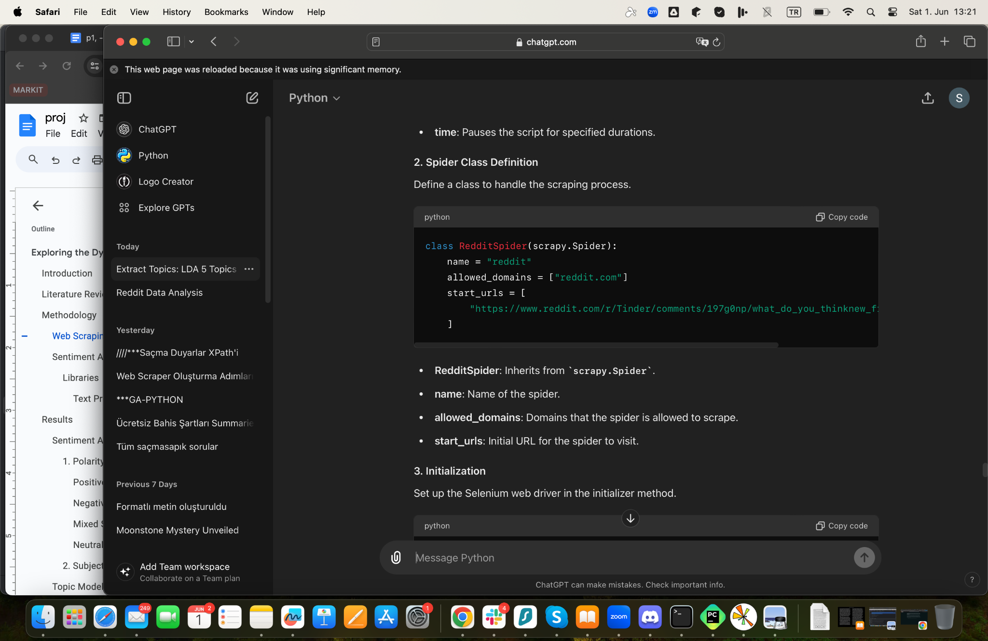

python

class RedditSpider(scrapy.Spider):

name = "reddit"

allowed_domains = ["reddit.com"]

start_urls = [

RedditSpider: A class that extends ‘scrapy.Spider’.

name: The name of this spider.

allowed_domains: The domains that the spider is allowed to scrape.

start_urls: The initial URL that the spider will visit to start scraping.

##### Initialization

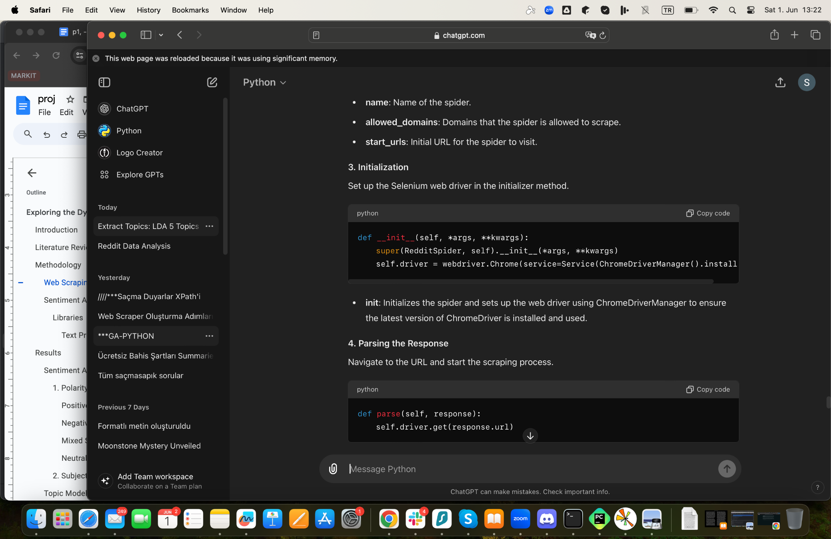

'__init__': This is the initializer method. It sets up the web driver using ChromeDriverManager, which ensures the latest version of ChromeDriver is installed and used.

python

def __init__(self, *args, kwargs):

super(RedditSpider, self).__init__(*args, kwargs)

Install ChromeDriver using WebDriverManager

self.driver = webdriver.Chrome(service=Service(ChromeDriverManager().install()))

##### Parsing the Response

Navigate to the URL and start the scraping process.

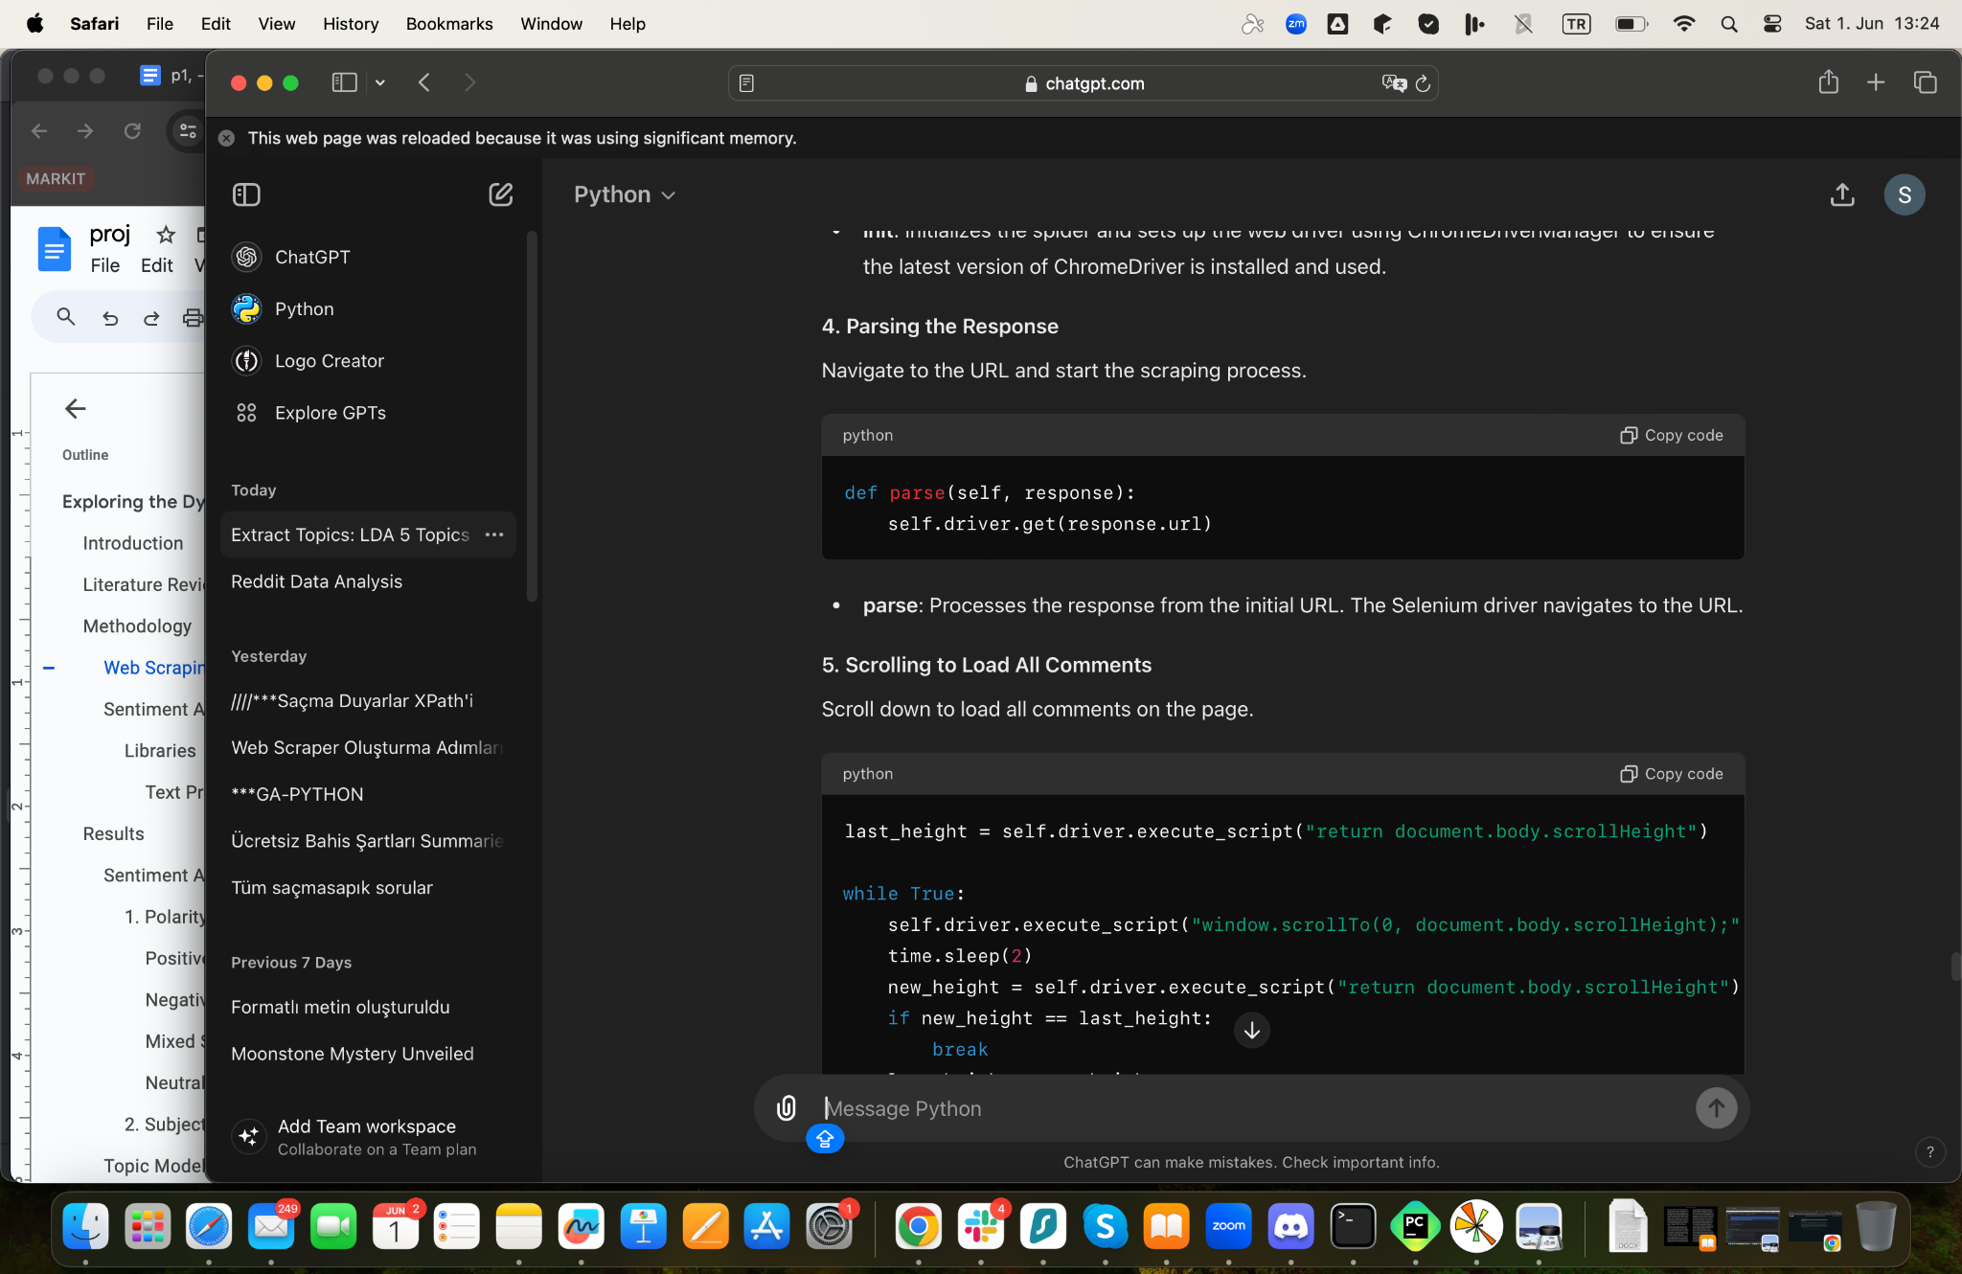

python

def parse(self, response):

self.driver.get(response.url)

'parse': This method processes the response from the initial URL. Here, the Selenium driver navigates to the URL.

Scrolling to Load All Comments

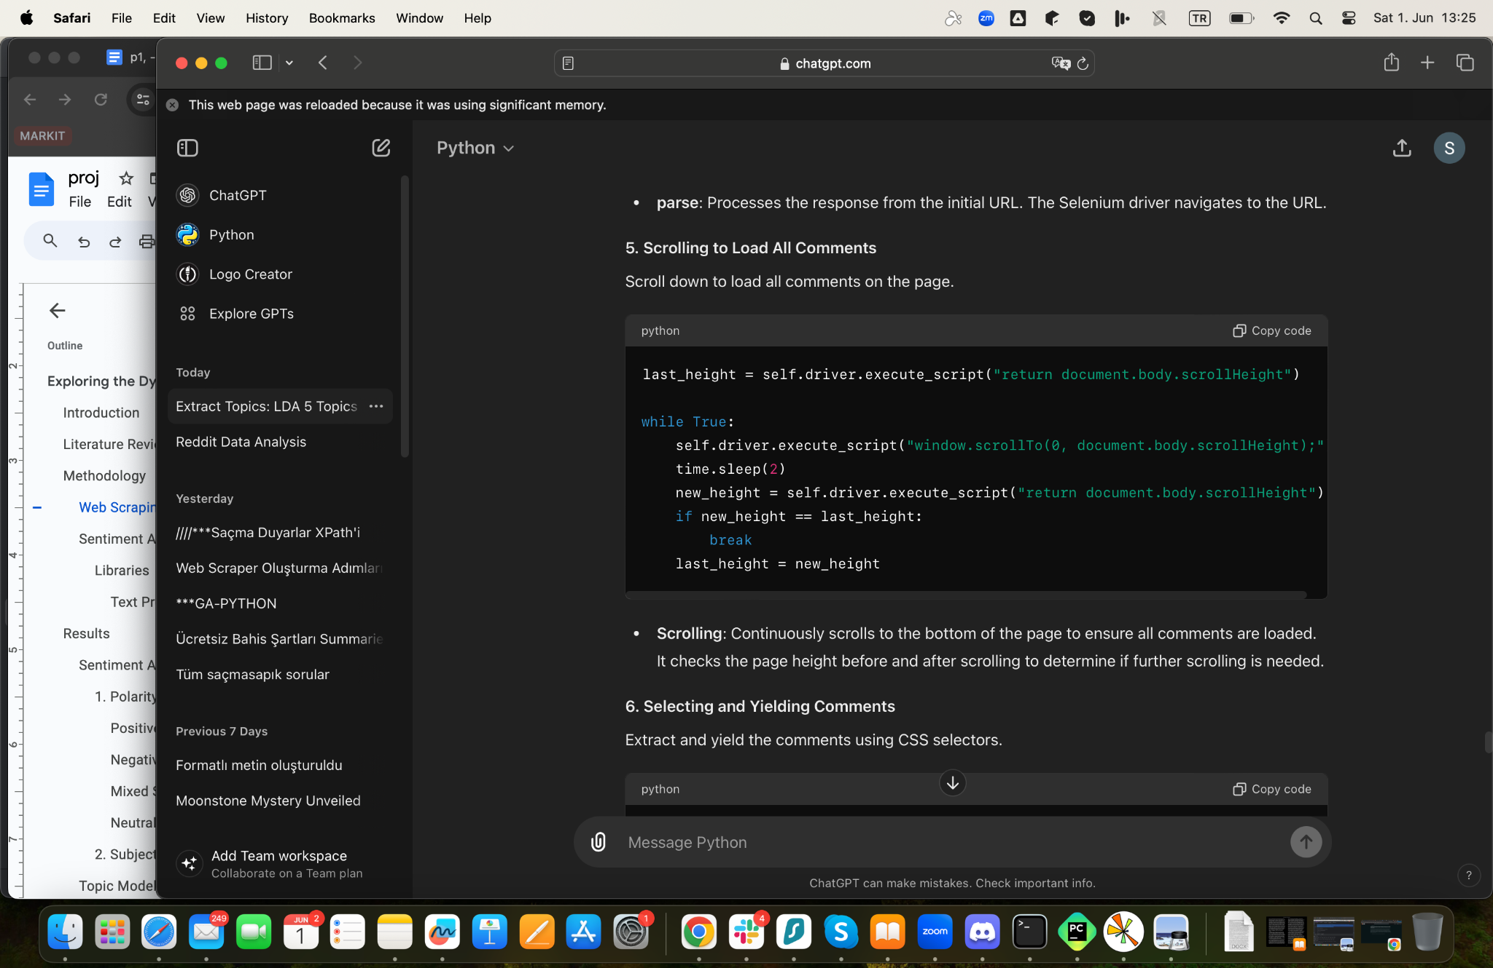

python

Scroll to the bottom of the page to load all comments

last_height = self.driver.execute_script("return document.body.scrollHeight")

while True:

self.driver.execute_script("window.scrollTo(0, document.body.scrollHeight);")

time.sleep(2) Wait for comments to load

new_height = self.driver.execute_script("return document.body.scrollHeight")

if new_height == last_height:

break

last_height = new_height

Scrolling: The code scrolls to the bottom of the page to ensure all comments are loaded. It checks the page height before and after scrolling to determine if it needs to scroll more.

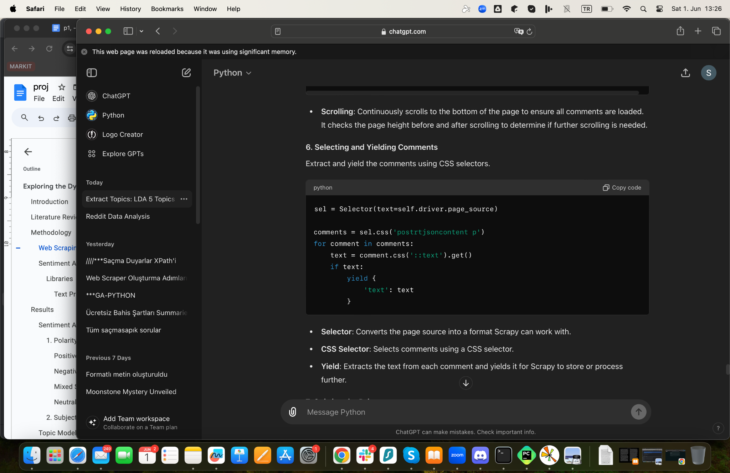

##### Selecting and Yielding Comments

python

sel = Selector(text=self.driver.page_source)

Use CSS selector to select main comments

comments = sel.css('postrtjsoncontent p')

for comment in comments:

text = comment.css('::text').get()

if text:

yield {

'text': text

}

Selector: Converts the page source (HTML) into a format that Scrapy can work with.

CSS Selector: Selects the comments using a CSS selector.

Yield: Extracts the text from each comment and yields it. Yielding means that the data is passed back to Scrapy to be stored or processed further.

##### Quitting the Driver

python

self.driver.quit()

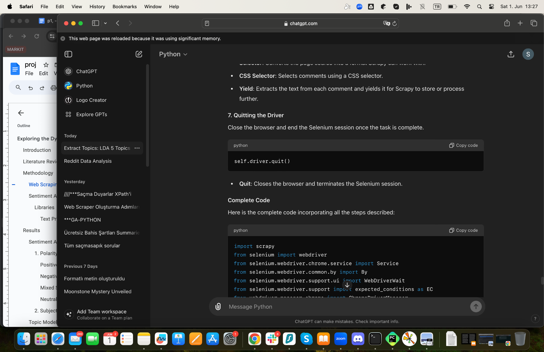

Quit: Closes the browser and ends the Selenium session.

##### Complete Code

python

import scrapy

from selenium import webdriver

from selenium.webdriver.chrome.service import Service

from selenium.webdriver.common.by import By

from selenium.webdriver.support.ui import WebDriverWait

from selenium.webdriver.support import expected_conditions as EC

from webdriver_manager.chrome import ChromeDriverManager

from scrapy.selector import Selector

import time

class RedditSpider(scrapy.Spider):

name = "reddit"

allowed_domains = ["reddit.com"]

start_urls = [

"https://www.reddit.com/r/Tinder/comments/197g0np/what_do_you_thinknew_friends_really_means/"

]

def __init__(self, *args, kwargs):

super(RedditSpider, self).__init__(*args, kwargs)

self.driver = webdriver.Chrome(service=Service(ChromeDriverManager().install()))

def parse(self, response):

self.driver.get(response.url)

last_height = self.driver.execute_script("return document.body.scrollHeight")

while True:

self.driver.execute_script("window.scrollTo(0, document.body.scrollHeight);")

time.sleep(2)

new_height = self.driver.execute_script("return document.body.scrollHeight")

if new_height == last_height:

break

last_height = new_height

sel = Selector(text=self.driver.page_source)

comments = sel.css('postrtjsoncontent p')

for comment in comments:

text = comment.css('::text').get()

if text:

yield {

'text': text

}

self.driver.quit()

### 3.2 Sentiment Analysis and Topic Modeling

#### 3.2.1 Libraries

First, I have imported several libraries. These libraries are collections of prewritten code that help us do specific tasks easily.

1. import re: This library helps to work with text using regular expressions (patterns used to find or replace text).

2. import nltk: This is a library for working with human language data (Natural Language Processing, or NLP).

3. from nltk.corpus import stopwords: This part of the nltk library gives a list of common words (like "the", "and", "is") to ignore in text analysis.

4. from nltk.tokenize import word_tokenize: This helps us split sentences into individual words.

5. from textblob import TextBlob: This library is used for simple text analysis, like finding out if the text is positive or negative (sentiment analysis).

6. from sklearn.feature_extraction.text import TfidfVectorizer: This helps to find important words in a collection of texts.

7. from sklearn.decomposition import LatentDirichletAllocation: This is a tool for discovering topics in a collection of texts.

Before I used NLTK, I had to download some data it needed:

python

nltk.download('punkt')

nltk.download('stopwords')

punkt: This is data for dividing text into words. It is specifically designed for tokenizing text, which includes segmenting text into sentences and words.

stopwords: This is a list of common words to ignore.

##### 3.2.2 Text Preprocessing

import re

import nltk

from nltk.corpus import stopwords

from nltk.tokenize import word_tokenize

from textblob import TextBlob

# Download required nltk packages

nltk.download('punkt')

nltk.download('stopwords')

def preprocess_text(text):

text = text.lower()

text = re.sub(r'\@\w+|\#', '', text)

text = re.sub(r'[^A-Za-z0-9\s]+', '', text)

# Tokenizing text

tokens = word_tokenize(text)

# Remove stop words (unnecessary words)

stop_words = set(stopwords.words('english'))

filtered_tokens = [word for word in tokens if word not in stop_words]

# Recombining tokens

clean_text = ' '.join(filtered_tokens)

return clean_text

text_list = [text

]

total_polarity = 0

total_subjectivity = 0

count = 0

# Sentiment analysis for each text

for text in text_list:

clean_text = preprocess_text(text)

blob = TextBlob(clean_text)

sentiment = blob.sentiment

print(f"Text: {text}")

print(f"Clean Text: {clean_text}")

print(f"Polarity: {sentiment.polarity}")

print(f"Subjectivity: {sentiment.subjectivity}")

print("------")

total_polarity += sentiment.polarity

total_subjectivity += sentiment.subjectivity

count += 1

# Calculating averages

average_polarity = total_polarity / count

average_subjectivity = total_subjectivity / count

print(f"Average Polarity: {average_polarity}")

print(f"Average Subjectivity: {average_subjectivity}")

The function “preprocess_text.” takes a piece of text and cleans it up so it is ready for analysis.

1. Convert to lowercase:

python

text = text.lower()

This makes all the letters in the text into small letters. This way, "Hello" and "hello" are treated as the same word.

1. Remove URLs:

python

text = re.sub(r'http\S+', '', text)

This removes web links from the text.

1. Remove @ and symbols:

python

text = re.sub(r'\@\w+|\', '', text)

This removes words starting with @ (like usernames) and (hashtags).

1. Remove special characters:

python

text = re.sub(r'[^AZaz09\s]+', '', text)

This removes anything that is not a letter, number, or space.

1. Split text into words (tokenize):

python

tokens = word_tokenize(text)

This splits the text into individual words.

1. Remove stopwords:

python

stop_words = set(stopwords.words('english'))

filtered_tokens = [word for word in tokens if word not in stop_words]

This removes common words that don't add much meaning to the text (like "the", "and").

1. Rejoin words into a single string:

python

clean_text = ' '.join(filtered_tokens)

This joins the cleaned words back into a single piece of text.

Finally, the function returns the cleaned text:

python

return clean_text

The complete function, with comments explaining each step:

python

def preprocess_text(text):

text = text.lower() Convert text to lowercase

text = re.sub(r'http\S+', '', text) Remove URLs

text = re.sub(r'\@\w+|\', '', text) Remove @ and symbols

text = re.sub(r'[^AZaz09\s]+', '', text) Remove special characters

tokens = word_tokenize(text) Split text into words

stop_words = set(stopwords.words('english')) Get list of common words to ignore

filtered_tokens = [word for word in tokens if word not in stop_words] Remove common words

clean_text = ' '.join(filtered_tokens) Rejoin words into a single string

return clean_text Return the cleaned text

## 

## 4. Results

#### 4.1 Sentiment Analysis

Polarity and Subjectivity: The polarity scores, which measure the positivity or negativity of the comments, vary widely. While some users express positive experiences and optimism (e.g., “tinder real hook friends make along way”), others share negative experiences and skepticism (e.g., “cheating slut confirmed makes absolutely disgusted”).

1. Polarity and Subjectivity:

The average polarity of 0.05 indicates that the overall sentiment is slightly positive, suggesting that while there are challenges, people generally have some positive experiences or hopes when it comes to forming friendships through dating apps.

The average subjectivity of 0.3 indicates a moderate level of subjectivity, suggesting that personal opinions and experiences heavily influence the discourse around this topic.

Examples and Insights:

1. Positive Experiences:

"made good friend bumble date busy decided hang instead" (Polarity: 0.4, Subjectivity: 0.45) - This comment reflects a positive outcome where a potential date turned into a lasting friendship.

"met good eggs bumble bff app" (Polarity: 0.7, Subjectivity: 0.6) - This reflects a highly positive experience, emphasizing the success of using the app to form meaningful connections.

1. Challenges and Concerns:

"know every male friend ever made dating app tried sleep" (Polarity: 0.0, Subjectivity: 0.1) - This highlights a common issue where attempts at friendship can be complicated by sexual interest.

"bumble bff helps find friends" (Polarity: 0.0, Subjectivity: 0.0) - Indicates a neutral statement acknowledging the utility of the app without strong emotional weight.

1. Mixed Experiences:

"use dating apps absolutely reddit guys girls dinner gamed went hiking seen movies etc you find good people anywhere youre open it yes several times hasn't strong mutual attraction fun things often develop naturally towards friendship" (Polarity: -0.089, Subjectivity: 0.63) - Reflects the nuanced nature of forming friendships, where outcomes vary widely based on mutual attraction and individual openness.

"found one party rejects relationship unlikely rejected person truly interested platonic friendship yes well know last far one guy met amazing golden retriever energy fantastically fun blast snowboarding together let crash extremely clear crash smash offer respectful made little bit next times saw sex town awhile started dating someone else planned ride staying told couldn't stay asked told seeing someone super cool still ride together blast hasn't weird feel like going stay legitimate friends think works blast found attractive neither us super invested dating sex" (Polarity: 0.145, Subjectivity: 0.53) - Shows the possibility of genuine friendships forming even if there was initial romantic or sexual interest.

#### 4.1.1 Polarity:

This indicates the sentiment of the comments, with values ranging from 1 (negative sentiment) to +1 (positive sentiment). The comments generally exhibit a mix of positive, neutral, and negative sentiments:

Comments with high positive polarity (e.g., 0.6) reflect favorable experiences or positive opinions about using dating apps for friendship.

Comments with negative polarity (e.g., -0.8) indicate dissatisfaction or criticism.

Neutral polarity (0.0) comments are factual or indifferent without strong sentiment.

##### Positive Sentiments:

Some users express positive outcomes from using dating apps for friendships, citing successful transitions from potential romantic interests to close friends. Some have made friends using Tinder and other dating apps, finding the experience enjoyable and fulfilling. Examples include comments about maintaining longterm friendships and the ease of meeting new people. For example, comments with polarity scores like 0.6 reflect satisfaction with forming lasting friendships through these platforms.

Apps like Bumble BFF are mentioned positively, with users appreciating the friendfinding feature.

##### Negative Sentiments:

Negative sentiments often stem from misunderstandings, such as users who felt their intentions for platonic relationships were not respected, leading to discomfort or disappointment. There is skepticism and criticism regarding the use of dating apps for friendships. For example, some users find it inappropriate or ineffective, as indicated by comments with negative polarity scores. Concerns about the genuine intentions of people using these apps (e.g., users posing as friends but seeking hookups) are prevalent in comments with negative sentiment. Other concerns include the perception that using dating apps for friendships might be seen as inappropriate or insincere.

##### Mixed Sentiments:

Mixed sentiments reflect the complexity of using dating apps for friendships. Some users appreciate the functionality but also highlight significant drawbacks, like the potential for miscommunication or the challenge of maintaining clear boundaries.

##### Neutral/Factual Insights:

Some comments provide factual statements about the features of apps like Tinder and Bumble BFF, indicating that these platforms include options for seeking friendships.

The objective comments often describe personal experiences without strong emotional undertones, focusing on the practical aspects of using these apps for nonromantic connections.

#### 4.1.2 Subjectivity:

This measures the degree of personal opinion versus factual information, ranging from 0 (objective) to 1 (subjective):

Comments with high subjectivity (e.g., 1.0) reflect personal opinions or emotions.

Low subjectivity (e.g., 0.0) comments are more objective and factbased.

Specific Comments

Comment such as “bio says friends expect anything” reflect the straightforward use of profiles to set clear expectations.

Statements such as “looking someone friendzone realized dating site date” highlight the potential for dating apps to facilitate friendships but also acknowledge the primary purpose of these platforms.

Personal stories, such as “10 years ago met late wife old version okcupid originally chat buddy,” illustrate the diverse outcomes of using dating apps, ranging from lifelong friendships to serious romantic relationships.

In summary, while forming friendships through dating apps seems to be full of complexities, there is a general sense of hope and positivity, underscored by personal anecdotes of success and camaraderie. Apps like Bumble BFF are highlighted as useful tools for forming friendships, indicating a recognition of the need for platforms that facilitate platonic connections alongside romantic ones.

The sentiment around forming friendships through dating apps is cautiously optimistic. People recognize the potential for meaningful connections but are also wary of the complications that can arise from mixed signals and differing intentions. Followingly, experiences are diverse, with some people successfully transitioning from potential romantic partners to close friends, while others face challenges such as unreciprocated romantic interest or misaligned expectations.

### 4.2 Topic Modeling and Text Mining Methods

### 4.2.1 Topic Modeling

import re

import nltk

from nltk.corpus import stopwords

from nltk.tokenize import word_tokenize

from textblob import TextBlob

from sklearn.feature_extraction.text import TfidfVectorizer

from sklearn.decomposition import LatentDirichletAllocation

nltk.download('punkt')

nltk.download('stopwords')

def preprocess_text(text):

text = text.lower()

text = re.sub(r'http\S+', '', text) # Remove URLs

text = re.sub(r'\@\w+|\#', '', text) # Remove @ and #

text = re.sub(r'[^A-Za-z0-9\s]+', '', text) # Remove special characters

tokens = word_tokenize(text)

stop_words = set(stopwords.words('english'))

filtered_tokens = [word for word in tokens if word not in stop_words]

clean_text = ' '.join(filtered_tokens)

return clean_text

comments = ["text"]

clean_comments = [preprocess_text(comment) for comment in comments]

print(clean_comments)

for comment in clean_comments:

blob = TextBlob(comment)

sentiment = blob.sentiment

print(f"Comment: {comment}")

print(f"Polarity: {sentiment.polarity}, Subjectivity: {sentiment.subjectivity}")

vectorizer = TfidfVectorizer(max_features=10)

X = vectorizer.fit_transform(clean_comments)

keywords = vectorizer.get_feature_names_out()

print(keywords)

lda = LatentDirichletAllocation(n_components=4, random_state=42)

X_topics = lda.fit_transform(X)

terms = vectorizer.get_feature_names_out()

for index, topic in enumerate(lda.components_):

print(f"Topic {index + 1}:")

print([terms[i] for i in topic.argsort()[-10:]])

The topic modeling analysis on the subject of forming friendships through dating apps like Tinder and Bumble BFF reveals several key insights. The comments are categorized into two main topics based on the frequently used words:

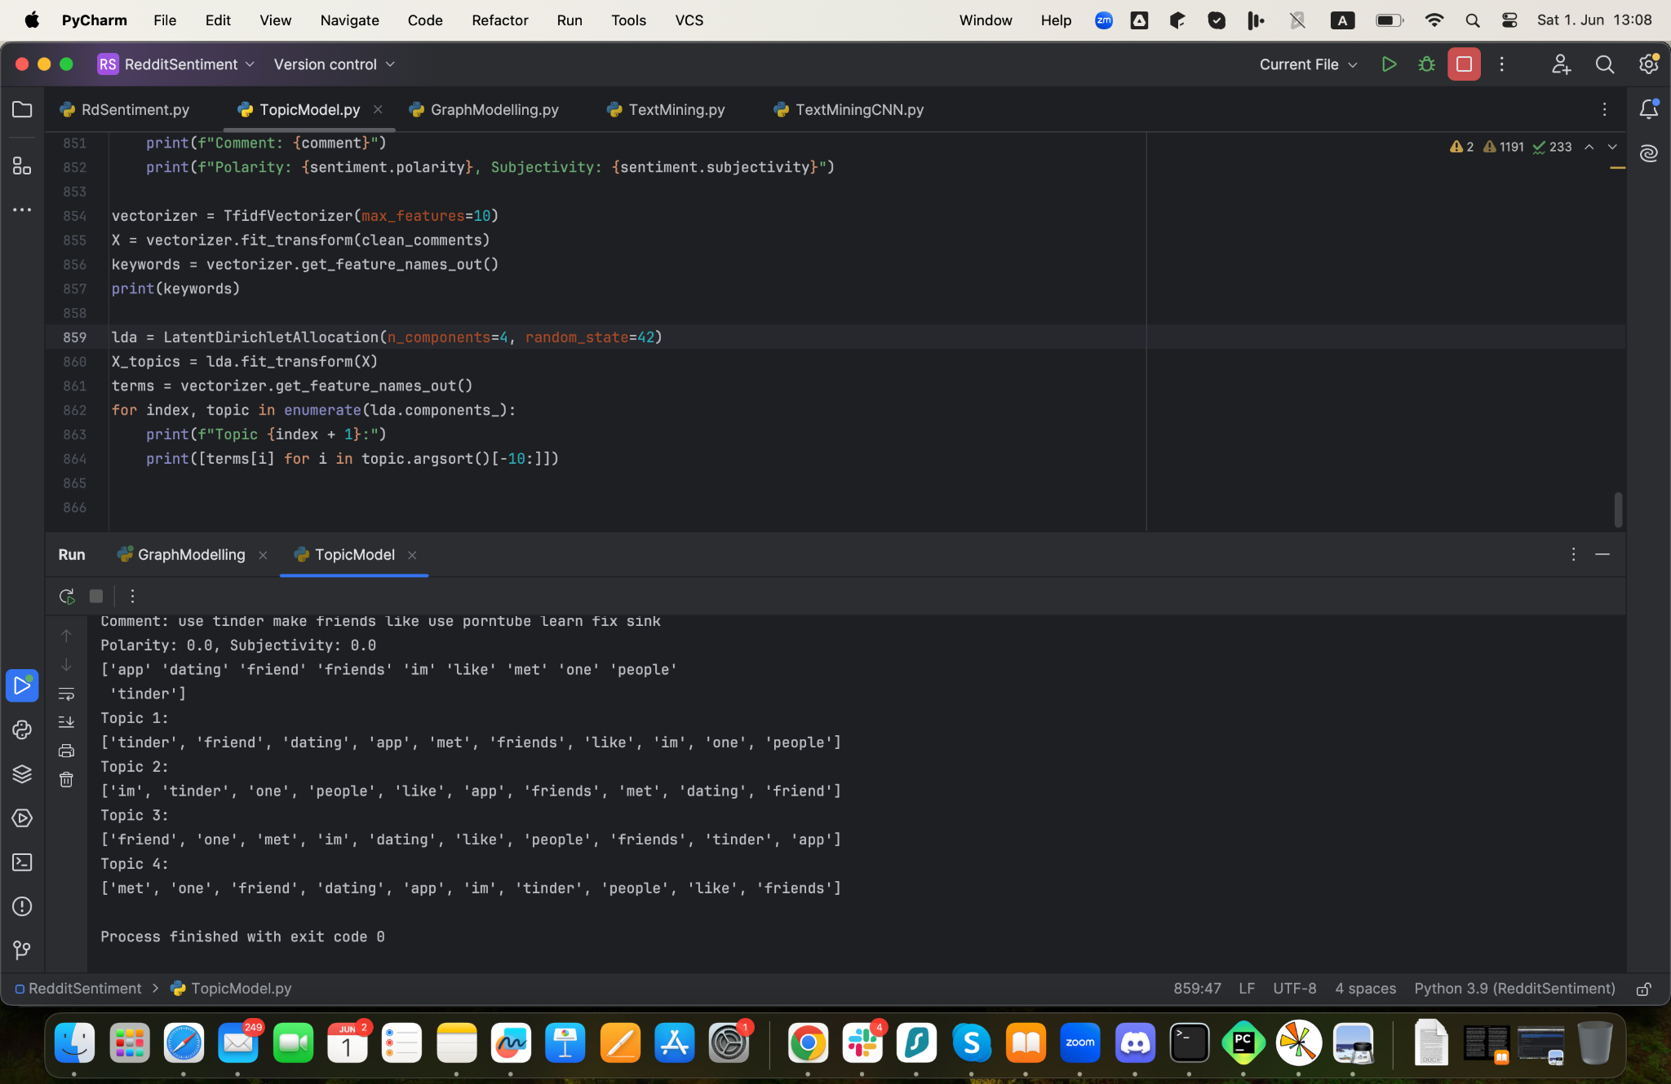

These topics center on experiences and opinions related to using Tinder for making friends, with users discussing their interactions, whether they successfully made friends, and their general sentiments towards using a dating app for this purpose.

The similarity in the words between the four topics in the topic modeling results could be due to several reasons. First, overlapping content within the dataset might lead to the identification of similar terms in multiple topics. Additionally, specifying only two topics may result in insufficient granularity to distinguish distinct themes, causing similar words to appear in both topics. Dominant themes, such as 'tinder', 'dating', 'friend', and 'people', might be pervasive throughout the dataset, making them common across topics. Lastly, a small dataset or a limited range of discussed topics can lead to the recurrence of the same set of words in different contexts, resulting in similar word lists for different topics.

Therefore, I have tried the text mining method to see alternative results and put the scraped data.

### 4.2.2 Text Mining

from sklearn.feature_extraction.text import CountVectorizer

from sklearn.decomposition import LatentDirichletAllocation

# Example text data

documents = ["text"

]

# Initialize CountVectorizer

vectorizer = CountVectorizer(stop_words='english')

# Transform the text data into document-term matrix

X = vectorizer.fit_transform(documents)

# Number of topics

n_topics = 5

# Initialize and fit the LDA model

lda = LatentDirichletAllocation(n_components=n_topics, random_state=42)

lda.fit(X)

# Display topics

for index, topic in enumerate(lda.components_):

print(f"Topic #{index + 1}:")

print([vectorizer.get_feature_names_out()[i] for i in topic.argsort()[-10:]])

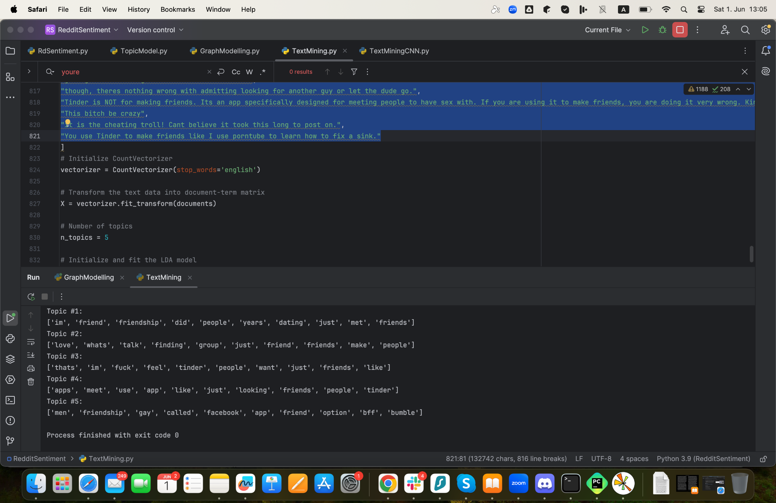

The text mining results you obtained from PyCharm reveal several topics identified from the dataset. Analyzing these topics helps in understanding the prominent themes discussed within the text. Here is a detailed analysis of each topic:

Topic 1:

Words: ['im', 'friend', 'friendship', 'did', 'people', 'years', 'dating', 'just', 'met', 'friends']

This topic appears to focus on personal experiences and relationships formed over the years. The words "friend", "friendship", "met", and "friends" indicate a theme around forming and maintaining friendships. The inclusion of "dating" suggests that these friendships may have originated from dating contexts.

Topic 2:

Words: ['love', 'whats', 'talk', 'finding', 'group', 'just', 'friend', 'friends', 'make', 'people']

This topic seems to revolve around the broader concept of finding connections and forming groups. Words like "love", "finding", "group", and "make" suggest discussions about creating meaningful relationships and social groups. The repeated mention of "friend" and "friends" reinforces the focus on social connections.

Topic 3:

Words: ['thats', 'im', 'fuck', 'feel', 'tinder', 'people', 'want', 'just', 'friends', 'like']

This topic includes a mix of casual and more intense expressions related to interactions on dating apps. The presence of words like "fuck", "feel", "tinder", and "want" suggests conversations around emotional and physical experiences on Tinder. The words "friends" and "like" indicate a mix of casual interactions and the desire for friendships.

Topic 4:

Words: ['apps', 'meet', 'use', 'app', 'like', 'just', 'looking', 'friends', 'people', 'tinder']

This topic is centered around the use of dating and social apps. The words "apps", "meet", "use", "app", and "tinder" highlight discussions about how people use various applications to meet others. "Looking" and "friends" suggest the intention behind using these apps, whether for friendships or dating.

Topic 5:

Words: ['men', 'friendship', 'gay', 'called', 'facebook', 'app', 'friend', 'option', 'bff', 'bumble']

This topic focuses on specific demographics and platforms. Words like "men", "gay", "facebook", "app", "option", "bff", and "bumble" indicate discussions about friendships among men, possibly within the gay community, and the use of specific apps like Facebook and Bumble BFF for forming these connections.

The repetition of certain words across topics, such as "friend", "friends", "app", "people", and "just", indicates common themes related to forming friendships and using social/dating apps. This repetition can be attributed to the overlapping content within the dataset, where similar themes are discussed in different contexts. Each topic, while having unique elements, shares common ground in discussing social connections, the use of technology in forming relationships, and personal experiences in these domains. The presence of dominant themes, such as the use of apps and the nature of friendships, leads to the recurrence of similar words across multiple topics.

### 5. Discussion

The analysis of user comments on friendships formed through dating apps reveals a complex interplay of positive and negative experiences. While topic modeling and text mining provided an initial understanding, a more detailed manual review helped me to uncover a richer set of keywords that better capture the full spectrum of user sentiments.

1. Dating Apps for friendships:

Many users are discussing the potential and challenges of using dating apps like Tinder and Bumble BFF to form friendships instead of romantic or sexual relationships. The core topic centers around how these platforms can be repurposed for platonic connections.

Despite the skepticism, there are also positive experiences. Some users have successfully made lasting friendships through dating apps. These friendships often start with an initial romantic interest that transitions into platonic friendship after realizing romantic incompatibility.

Words: solid friends, genuine connection, hyped, community, fun, supportive, safe, positive interactions, cool, appreciate, fun, enjoy, grateful

1. User intentions:

There is a recurring theme of users specifying their intentions on these apps, such as clearly stating they are looking for friends to avoid misunderstandings or mismatches. This reflects the importance of clear communication of intentions on these platforms.

1. Challenges and misunderstandings:

Challenges include the risk of users misinterpreting friendship intentions as romantic interest, leading to potential misunderstandings. There are mentions of people trying to maintain boundaries and the importance of respecting these boundaries. Many users find it challenging to maintain purely platonic relationships initiated through dating apps. There is a recurring theme that these friendships can fade once one party enters a romantic relationship or if there is any lingering romantic interest.

Words: monetized, struggle, awkward, difficult, limited opportunities, isolation, inconvenient, challenging, unreliable, time-consuming, frustration, disappointment, misunderstood, uncomfortable, barriers

Many users express skepticism about the efficacy of dating apps for making platonic friends. They often mention that even when apps have features designed for friendship, such as Bumble BFF, they can still be misused for romantic or sexual pursuits. Users frequently encounter others who are not genuinely interested in friendship but are instead looking for romantic or sexual connections.

Words: scammers, nutters, hookup, exploiting, fake, sus (suspicious), ghosting, trolling, creeps, predators, jealousy, cheating, regret, harassment, red flag

Positive experiences: Many users describe their interactions on dating apps using terms like 'solid friends,' 'genuine,' 'connection,' 'fun,' 'supportive,' and 'grateful.' These keywords suggest that, for some, dating apps are a valuable tool for forming meaningful and supportive friendships. Positive interactions are often highlighted, emphasizing the potential for dating apps to foster genuine community connections.

Challenges and negative experiences: Conversely, keywords such as 'struggle,' 'awkward,' 'difficult,' 'isolation,' 'frustration,' and 'ghosting' reflect the significant challenges users face. These terms underscore the emotional and practical difficulties of navigating friendships on dating apps, including issues of trust, reliability, and the potential for negative interactions such as harassment and trolling.

The combination of automated and manual analysis underscores the need for a multifaceted approach to understanding user experiences. By integrating algorithmic insights with detailed keyword analysis, this report provides a comprehensive view of the dynamics of friendships formed through dating apps, highlighting both the opportunities and challenges inherent in these interactions.

## 6. Conclusion

The exploration into the dynamics of friendships formed through dating apps, based on the analysis of Reddit entries, provides an understanding of how these platforms are used for platonic connections. This study highlights both the potential and challenges of leveraging dating apps for friendships, reflecting diverse user experiences and sentiments.

Many users report forming meaningful and lasting friendships through dating apps like Tinder and Bumble BFF. These stories often involve clear communication of intentions and mutual respect for boundaries. Examples include users transitioning from romantic interests to close friends or finding supportive and fun companions through these platforms.

Features specifically designed for friendships, such as Bumble BFF, receive positive feedback for facilitating non-romantic connections. Users appreciate the ability to meet like-minded individuals and expand their social circles in otherwise challenging circumstances.

On the other hand, a significant number of users express frustration with misunderstandings, where friendship intentions are misinterpreted as romantic or sexual interest. This highlights the importance of clear communication and setting expectations upfront. Some users report encountering others who misuse friendship features for romantic pursuits, leading to uncomfortable and sometimes inappropriate interactions.

There is a prevalent skepticism about the efficacy of dating apps for forming genuine friendships. Users often mention issues like scammers, fake profiles, and people exploiting the platform for hookups rather than friendships. Concerns about the sincerity of other users and the potential for awkward or disappointing experiences are common, reflecting the mixed success of these apps in fostering true friendships.

The sentiment analysis revealed a slightly positive overall sentiment, with an average polarity of 0.055 (%52,75) and an average subjectivity of 0.314 (%65,7). This indicates that while users have some positive experiences, personal opinions and emotions heavily influence the discourse around this topic. The emotional landscape is varied, with users sharing both positive anecdotes and critical perspectives.

The analysis identified several recurring themes, such as the use of dating apps for platonic connections, personal experiences of friendship formation, and the challenges of maintaining clear boundaries. Specific demographics and platforms were discussed, highlighting the varied use of apps like Tinder and Bumble BFF among different user groups.

Followingly, common words like "friend," "friendship," "dating," "app," and "people" appeared frequently across topics, indicating the central focus on forming social connections and navigating the complexities of these relationships through digital platforms.

The mixed reception and diverse experiences suggest that while dating apps can be a valuable tool for making friends, their success largely depends on the users' clarity of purpose and the ability to manage potential misunderstandings. This research contributes to a deeper understanding of the social dynamics at play and highlights the need for continued exploration into the broader implications of digital interactions on human relationships.

There is a mixed reception towards using dating apps for making friends, with a considerable number of users expressing both positive outcomes and frustrations. The variability in sentiments suggests diverse personal experiences and expectations, highlighting that while some find these apps useful for expanding their social circle, others encounter challenges or unmet expectations. The discussions also point to a broader issue of modern social interactions and the difficulty of making genuine friendships in adulthood, prompting some users to explore unconventional methods like dating apps to meet new people.

Overall, the comments reflect a nuanced view of the utility of dating apps for friendships, with sentiments varying widely based on individual experiences and perceptions.

## 

## 

## Reddit Data Entries

<https://www.reddit.com/r/Tinder/comments/197g0np/what_do_you_thinknew_friends_really_means/>

<https://www.reddit.com/r/OnlineDating/comments/14e1dl5/girls_who_select_looking_for_new_friends_on_tinder/>

<https://www.reddit.com/r/Tinder/comments/15vbms8/whats_the_deal_with_people_only_looking_for/>

<https://www.reddit.com/r/datingoverthirty/comments/u2r70q/have_you_made_legitimate_lasting_friendships_with/>

<https://www.reddit.com/r/Tinder/comments/5kdsfy/using_tinder_for_friends_only_bf_is_being_weird/>

<https://www.reddit.com/r/unpopularopinion/comments/cbc6kb/people_who_are_only_looking_for_friends_on_tinder/>

<https://www.reddit.com/r/RandomThoughts/comments/14ovqfl/there_should_be_an_app_like_tinder_but_for/?rdt=55429>

## Bibliography

Al-Tameemi, Israa K. Salman, Mohammad‐Reza Feizi‐Derakhshi, Saeed Pashazadeh, and Mohammad Asadpour. 2022. “A Comprehensive Review of Visual-Textual Sentiment Analysis From Social Media Networks.” *ResearchGate*, July. https://doi.org/10.48550/arxiv.2207.02160.

Anschütz, Miriam, Tobias Eder, and Georg Groh. 2023. “Retrieving Users’ Opinions on Social Media with Multimodal Aspect-Based Sentiment Analysis.” *IEEE*, February. <https://doi.org/10.1109/icsc56153.2023.00008>.

Bhandari, Vitthal, and Poonam Goyal. 2022. “bitsa_nlp@LT-EDI-ACL2022: Leveraging Pretrained Language Models for Detecting Homophobia and Transphobia in Social Media Comments.” *Association for Computational Linguistics*, January. https://doi.org/10.18653/v1/2022.ltedi-1.18.

Das, Manirupa, and Renhao Cui. 2019. “Comparison of Quality Indicators in User-generated Content Using Social Media and Scholarly Text.” *arXiv*, http://arxiv.org/pdf/1910.11399.pdf.

De Figueiredo, Flávio Pimenta, Jussara M. Almeida, Marcos André Gonçalves, and Fabrí­Cio Benevenuto. 2016. “TrendLearner: Early Prediction of Popularity Trends of User Generated Content.” *Information Sciences* 349–350 (July): 172–87. https://doi.org/10.1016/j.ins.2016.02.025.

Gupta, Anushree, Denny George, Kruttika Nadig, and Tarunima Prabhakar. 2020. “Check Mate: Prioritizing User Generated Multi-Media Content for Fact-Checking.” *arXiv*, <http://arxiv.org/pdf/2010.13387.pdf>.

Jalal, Mona, Kaihong Wang, Sankara Jefferson, Yi Zheng, Elaine O. Nsoesie, and Margrit Betke. 2019. “Scraping Social Media Photos Posted in Kenya and Elsewhere to Detect and Analyze Food Types.” *MadiMa*, October. <https://doi.org/10.1145/3347448.3357170>.

Poojitha, K., A. Sai Charish, M. Arun Kuamr Reddy, and S. Ayyasamy. 2023. “Classification of Social Media Toxic Comments Using Machine Learning Models.” ResearchGate.

Li, Xiaoya, Mingxin Zhou, Jiawei Wu, Arianna Yuan, Fei Wu, and Jiwei Li. 2020. “Analyzing COVID-19 on Online Social Media: Trends, Sentiments and Emotions.”. https://doi.org/10.48550/arxiv.2005.14464.

Liu, Yi, Pınar Yildirim, and Z. John Zhang. 2021. “Social Media, Content Moderation, and Technology.” *arXiv*. https://doi.org/10.48550/arxiv.2101.04618.

Meneghello, James, Nik Thompson, Kevin Lee, Kok Wai Wong, and Bilal Abu-Salih. 2020. “Unlocking Social Media and User Generated Content as a Data Source for Knowledge Management.” *International Journal of Knowledge Management* 16 (1): 101–22. https://doi.org/10.4018/ijkm.2020010105.

Xu, Zhao‐Dong, Zhenghao Liu, Yukun Yan, Zhiyuan Liu, Chenyan Xiong, and Gui Yu. 2024. “Cleaner Pretraining Corpus Curation With Neural Web Scraping.” *arXiv*. https://doi.org/10.48550/arxiv.2402.14652.